44.37: a) 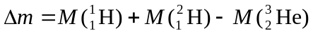where atomic masses are used to balance electron masses.
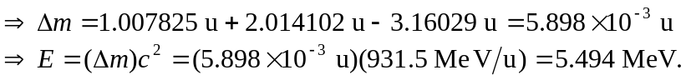
b) 